Smart Farming With AI and IOT

Yadidiah Kanaparthi  
Computer Science  
Canadian University DubaiDubai, UAE  
20210001705@students.cud.ac.ae

Majed Alzenati  
Computer Science  
Canadian University DubaiDubai, UAE 20210001826@students.cud.ac.ae

Abdul Karim Shaikh  
Computer Science  
Canadian University DubaiDubai, UAE  
202100021156@students.cud.ac.ae

Inaya Imtiyaz Khan  
Computer Science  
Canadian University DubaiDubai, UAE  
20210001536@students.cud.ac.ae

***Abstract*—“ … ”**

# Introduction

The world population is increasing drastically which will require more agriculture products. According to data from The food and Agriculture Organization (FAO) of the United

Nations the world’s population will increase to 9.8 billion people by 2050 and additional 50% of the current food production is needed for this population increase. AI can be used to improve crop planting efficiency, by improving quality and quantity of the crops [1]. IOT systems like drones can make it efficient to manage crop fields more efficiently as drones can plant more than 500 seeds of crop per hour than compared to 800 seeds planted by farmers per day [2]. These technical advancements not only increase productivity in the farm but also reduce farmer’s workload as well as reducing labor cost while also providing with detailed monitoring analytics of their produce [3]. Using IoT in has made a positive impact in agriculture research in this field is continually expanding, Farmers can maximize their land's potential by using this technology. IoT uses site-specific strategies to protect the environment and promote sustainability. According to expert forecasts, the global smart farming market is expected to experience significant growth, with projections indicating a rise from $14.65 billion in 2021 to $66 billion by 2030, corresponding to a compound annual growth rate (CAGR) exceeding 18% during the period from 2022 to 2030 [12]. IoT makes it easier to collect and process data collected from sensors to make detailed and visual analysis, IoT makes remote farm monitoring possible allowing farmers have their crop information from any location at any time. Predictive analytics algorithms can be used with data from sensors to estimate variables like crop productivity and the best times to plant and harvest [13]. With the help of these predictions, farmers can make informed choices that can boost crop quality, productivity, and production.

Precision farming maximizes resource efficiency while minimizing waste and environmental effects by precisely controlling resources such as water, fertilizers, and pesticides based on real-time data and forecast insights. By lowering input prices, this strategy helps farmers both financially and in terms of sustainable farming practices. The integration of IoT in agriculture transforms how farmers manage their operations and provides several benefits. IoT-ML based agriculture is the next evolutional thing in smart agriculture. Applying ML to data generated from various IoT devices can help provide definitive information and richer insights for crop production improvements [4]. Ultimately, IoT in agriculture is a key driver for achieving sustainability, increasing productivity, and meeting the challenges posed by a growing global population, farmers can increase crop yields, streamline processes, and guarantee the long-term sustainability of food production systems in a rapidly evolving environment [14]. Based on this introduction This paper aims to find how actually the IoT obtained data can be used to get detailed farm analysis and crop improvement with the help of ML?

# Literature Review

Sarkar et al. [1] explored the impact of AI in crop automation and found Robotics have revolutionized various aspects of crop management like harvesting, growth monitoring, picking, sorting, and packing. Drones play a major role in managing many operations like spraying, monitoring crop health, disaster management, and soil analysis with the help of Advanced computer vision [5], But adoption of these innovative technologies is still less due to a lack of awareness, and skills to utilize these technologies, additionally implementing robotics in farming increases costs and complexity issues leading to low IoT adoption. Paper by Han [6] has a similar result which argues about the lack of awareness prevents implementation of these systems, and mentioned that implementing technology in agriculture has benefics to both producers and consumens.

According to Aggarwal and Singh [7], farmers deal with a variety of challenges in agriculture, including irrigation management, analyzing soil behavior, predicting crop development, and managing disease. discusses weather forecasting plays an important role in addressing these challenges. temperature fluctuations, precipitation patterns, and other meteorological phenomena directly affect the output of agriculture, and play an important part in tackling these issues.

Through the utilization of AI and IoT technology, farmers can obtain predictive analytics and real-time weather data to maximize crop yields, reduce resource consumption, and lessen the negative consequences of extreme weather occurrences. adoption of weather forecasting technologies are essential for ensuring sustainable agricultural practices and enhancing food security in the face of changing climatic conditions. [8] Also has similar results which found that in almost all fields of agriculture such as farm monitoring, irrigation, pest monitoring IoT techniques can be applied and the IoT system needs to integrate with other technologies like machine learning to deal with the vast amounts of agricultural data.

Benos et al. [9] conducted a review and found that majority of the articles have primarily focused on crop management with an increase in crop recognition, ML algorithms particularly Artificial Neural Networks (ANNs), have been widely utilized for handling heterogeneous data in agriculture there is also a growing interest for Ensemble Learning (EL) and Support Vector Machines (SVMs) demonstrate high accuracy for data analysis.

Gia et al. [10] argue that relying solely on traditional IoT architectures cannot guarantee that the systems work properly because cloudcentric IoT applications cannot be implemented in remote areas where the Internet is not stable or coverage is limited. In these situations data real-time data monitoring and processing is not possible, However, effective solutions like Edge and Fog computing offer numerous benefits including effictive sensor data, reduce network load and and the ability to be executed by small microcontrollers such as Raspberry Pi, Arduino or ESP32.

the paper [11] emphasizes on the importance of forecasting crop performance uncer various environmental conditions to enhance crop productivity and argues that existing IoT platforms are not designed to support near-real-time analysis of large data gathered from sensors. Thus highlighting the need for innovative smart farming solutions.

##### Methodology

In our Project first we have used already collected datasets. In total we have used 6 datasets for different functionalities of our research process we will dive into all of them. The first dataset we used contains the following attributes.

* N - ratio of Nitrogen content in soil
* P - ratio of Phosphorous content in soil
* K - ratio of Potassium content in soil
* temperature - temperature in degree Celsius
* humidity - relative humidity in %
* ph - ph value of the soil
* rainfall - rainfall in mm

the following attributes N, P, K can be collected by soil NPK sensor [16], the temperature and humidity can be collected using the DHT 11 sensor, Ph sensor can measure the acidity of liquids, rainfall can be measured by a Rain Guage in [15].

|  |  |  |  |  |  |  |  |
| --- | --- | --- | --- | --- | --- | --- | --- |
| **P** | **K** | **temperature** | **humidity** | | **ph** | **rainfall** | **label** |
| 35 | 25 | 24.0 | 61.1 | 7.0 | | 161.5 | coffee |
| 57 | 53 | 42.3 | 90.5 | 6.9 | | 74.9 | papaya |
| 57 | 41 | 21.4 | 84.9 | 5.8 | | 272.2 | rice |
| 126 | 204 | 23.1 | 92.8 | 6.4 | | 108.2 | apple |
| 67 | 22 | 29.8 | 69.4 | 6.6 | | 51.6 | lentil |

The table shows how the sample is structured, here the values are rounded to 1 decimal place but in the model, we have used the exact values. Using this dataset, we developed a crop recommendation model which uses the best ML model based on the accuracy score and its F1 score and predicts the optimal type of crop to plant based on the given environment conditions. For the optimal model evaluation various machine learning algorithms like decision tree, SVM, random forest, K-Nearest Neighbors (KNN), naive bayes, linear regression and logistic regression was used, after evaluating the optimal model based on various scores, the model with the highest accuracy, precision and F1 score was selected.

The next task which we worked on was crop yield predicting here datasets rainfall, yield, pesticides, and temp were combined in the yield dataset to create a data frame for predicting yield the data frame was then encoded from categorical to numerical, test and training sets were divided and a comparison between actual yield and predicted yield was formed. Furtuer analysis was performed over the dataset that gave additional valuable information over the merged dataset.

| **Area** | **Item** | **Year** | **Rainfall**  **(mm)** | **Pesticide**  **(Tonn)** | **Temp**  **(**°C) | **Yield**  **(hg/ha)** |
| --- | --- | --- | --- | --- | --- | --- |
| Zambia | Maize | 2004 | 1020.0 | 1670.0 | 20.79 | 19239 |
| Colombia | Yams | 2004 | 3240.0 | 1.1×105 | 27.3 | 117050 |
| Guyana | Maize | 1996 | 2387.0 | 289.9 | 27.11 | 11481 |
| India | Potatoes | 1991 | 1083.0 | 72133.0 | 25.99 | 162540 |
| Guinea | Plantains | 2010 | 1651.0 | 556.24 | 27.8 | 52256 |

Next, we predicted weather forecasting over the time series dataset having the following attributes.

* date - format YYYY-MM-DD
* meantemp - Mean temperature from daily 3-hour intervals .
* humidity - Humidity value for the day per cubic meter volume of air.
* wind_speed - measured in kmph.
* meanpressure - Pressure reading of weather measure in atm.

The Adafruit Anemometer Sensor can be used for measuring wind speed [17], the DCT 532 sensor can be used for measuring pressure readings. Then we preprocessed the dataset and performed the ARIMA model for time series data forecasting [18] and evaluated the model score with the help of evaluation metrics like Mean Squared Error.

##### Results

In this section, we will first dive in to the datasets, information the dataset can give, and then the prediction

model is evaluated and finally the uses of each function is described so that inmormed decisions can be performed using the final data.

Crop Recommendation dataset:

This dataset stores the valuse that can be used to predict crop types based on the inputs first lets take a look at the scatter plot that describes the importance of temperature and rainfall.

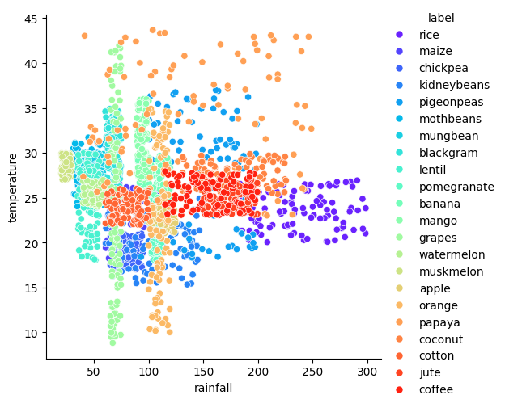

This scatter plot shows that most of the crops have the optimal temperature of 20-30°C and rainfall form 50-200 mm. Rice seems to be the only crop that needs rainfall over 200 mm. papaya can be grown in high temperatures ranging from 25-45°C, grapes and oranges can be grown in low temperatures. Although, grapes seems to grow in all temperatures ranging from 10-45°C.

The correlation matrix indicates arrtibutes with the highest correlation are Phosphorous and potassium, ph and Nitrogen and humidity and rainfall. Rainfall and nitrogen seem to have high correlation. We can say temperature and humidity are somewhat correlated. Using this correlation matrix, we can evaluate the best attributes to choose for feature selection, and it seems that all the attributes are important for evaluating the model. Comparing various models gives the table that can be used for crop recommendation.

|  |  |  |  |
| --- | --- | --- | --- |
| **Model** | **Accuracy** | **F1 score** | **Test time** |
| Decision Tree | 0.9709 | 0.9708 | 0.0013 |
| SVM | 0.9800 | 0.9798 | 0.0179 |
| Random Forest | 0.9855 | 0.9853 | 0.0037 |
| KNN | 0.9655 | 0.9649 | 0.0056 |
| Naive Bayes | 0.9909 | 0.9908 | 0.0016 |
| Linear Regression | 0.0636 | 0.0464 | 0.0015 |
| Logistic Regression | 0.9727 | 0.9727 | 0.0019 |

Based on the table we can evaluate that all models except the linear regression model had good accuracy and F1 scores.

Here naïve bayes classifier model has the best accuracy score following with Random forest and SVM models.

Here again naïve bayes classifier model has the best F1 score following with Random forest and SVM models. And the results found out that naïve bayes classifier model works well with data for Crop recommendation also works faster than other models as this model can be run in 1.6 Milliseconds.

Crop Yield prediction:

Directly from the dataset we can get valuable insights.

| **index** | **Year** | **yield** | **Avg**  **Rain** | **Pest** | **Avg**  **Temp** |
| --- | --- | --- | --- | --- | --- |
| **count** | 28242.0 | 28242.0 | 28242.0 | 28242.0 | 28242.0 |
| **mean** | 2001.54 | 77053.33 | 1149.06 | 37076.91 | 20.54 |
| **std** | 7.05 | 84956.61 | 709.81 | 59958.78 | 6.31 |
| **min** | 1990.0 | 50.0 | 51.0 | 0.04 | 1.3 |
| **25%** | 1995.0 | 19919.25 | 593.0 | 1702.0 | 16.7 |
| **50%** | 2001.0 | 38295.0 | 1083.0 | 17529.44 | 21.51 |
| **75%** | 2008.0 | 104676.75 | 1668.0 | 48687.88 | 26.0 |
| **max** | 2013.0 | 501412.0 | 3240.0 | 367778.0 | 30.65 |

Note: Avg = Average, Rain = Average Rainfall, Pest = Pesticides Tonnes, Temp = Average Temperature

We can find that there are over 28000 rows, the lowest yield is 50hg/ha and highest is 501412.0hg/ha. In average around 37000 tonnes of pesticides are being used in a country and the average temperature stays around 20.54°C.

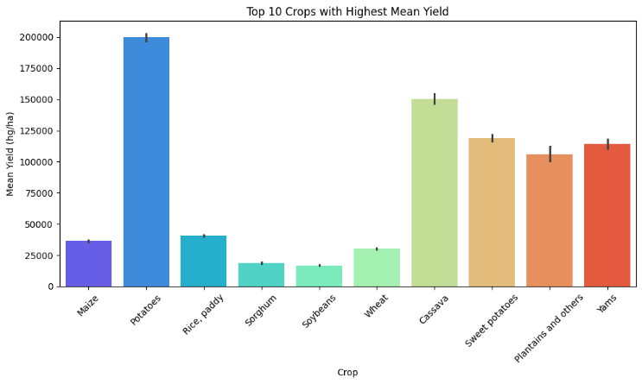the bargraph shows that potatoes is the highest grown crop following with Cassava, Sweet potatoes and Yams.

After analysis process, using the decision tree regressor model we found

From the graph we can see that as the actual values increase, the predicted values also tend to increase, also the values seem to be closer to the line of best fit, further evaluating to the model shows that R-squared: 0.961127696741854, this shows a stron g positive relationship between both values so the model was succesful in determining yield prediction.

For our last task which is weather forecasting for the time series related data,

This shows the average temperature in the location where data was collected from 2013 Jan to 2017 Jan. using the ARIMA model here gives forecasting predictions

Although some variation is shown between the test and prediction values, this model was still accurate as Mean Absolute Percentage Error was 0.05594606603916466, Mean Squared Error was 2.277060861384478 and Root Mean Squared Error was 1.5089933271504146 which is fairly low error values this indicated the model performs well for weather forecasting for crop efficiency.

##### Conclusion

##### References

1. Md. R. Sarkar, S. R. Masud, M. I. Hossen, and M. Goh, “A Comprehensive Study on the Emerging Effect of Artificial Intelligence in Agriculture Automation,” in 2022 IEEE 18th International Colloquium on Signal Processing & Applications (CSPA), Selangor, Malaysia: IEEE, May 2022, pp. 419–424. doi: 10.1109/CSPA55076.2022.9781883.
2. V. U. Tjhin and R. E. Riantini, “Smart Farming: Implementation of Industry 4.0 in the Agricultural Sector,” in 2022 6th International Conference on E-Commerce, E-Business and E-Government, Plymouth United Kingdom: ACM, Apr. 2022, pp. 115–120. doi: 10.1145/3537693.3537711.
3. Md. N. H. Sheham, M. T. Hassan, A. Imran, T. F. Ahmed, Md. S. Parvez, and A. Ahmed, “Design of an IoT-based Smart Farming System: IoT-based Smart Farming System,” in Proceedings of the 2nd International Conference on Computing Advancements, Dhaka Bangladesh: ACM, Mar. 2022, pp. 284–293. doi: 10.1145/3542954.3542996.
4. M. W. P. Maduranga and R. Abeysekera, “MACHINE LEARNING APPLICATIONS IN IOT BASED AGRICULTURE AND SMART FARMING: A REVIEW,” Int. J. Eng. Appl. Sci. Technol., vol. 04, no. 12, pp. 24–27, May 2020, doi: 10.33564/IJEAST.2020.v04i12.004.
5. E. Said Mohamed, Aa. Belal, S. Kotb Abd-Elmabod, M. A. El-Shirbeny, A. Gad, and M. B. Zahran, “Smart farming for improving agricultural management,” Egypt. J. Remote Sens. Space Sci., vol. 24, no. 3, pp. 971–981, Dec. 2021, doi: 10.1016/j.ejrs.2021.08.007.
6. D. Han, “Big Data Analytics, Data Science, ML&AI for Connected, Data-driven Precision Agriculture and Smart Farming Systems: Challenges and Future Directions,” in Proceedings of Cyber-Physical Systems and Internet of Things Week 2023, San Antonio TX USA: ACM, May 2023, pp. 378–384. doi: 10.1145/3576914.3588337.
7. N. Aggarwal and D. Singh, “Technology assisted farming: Implications of IoT and AI,” IOP Conf. Ser. Mater. Sci. Eng., vol. 1022, no. 1, p. 012080, Jan. 2021, doi: 10.1088/1757-899X/1022/1/012080.
8. S. Terence and G. Purushothaman, “Systematic review of Internet of Things in smart farming,” Trans. Emerg. Telecommun. Technol., vol. 31, no. 6, p. e3958, Jun. 2020, doi: 10.1002/ett.3958.
9. L. Benos, A. C. Tagarakis, G. Dolias, R. Berruto, D. Kateris, and D. Bochtis, “Machine Learning in Agriculture: A Comprehensive Updated Review,” Sensors, vol. 21, no. 11, p. 3758, May 2021, doi: 10.3390/s21113758.
10. T. N. Gia, L. Qingqing, J. P. Queralta, Z. Zou, H. Tenhunen, and T. Westerlund, “Edge AI in Smart Farming IoT: CNNs at the Edge and Fog Computing with LoRa”.
11. P. Jayaraman, A. Yavari, D. Georgakopoulos, A. Morshed, and A. Zaslavsky, “Internet of Things Platform for Smart Farming: Experiences and Lessons Learnt,” *Sensors*, vol. 16, no. 11, p. 1884, Nov. 2016, doi: 10.3390/s16111884.
12. A. Sydoruk. “10 Key Benefits of IoT in Agriculture and Farming.” smarttek.solutions. https://smarttek.solutions/blog/iot-in-agriculture/ (accessed Feb. 26, 2024).
13. M. Lerner. “How IoT Precision Agriculture And Smart Farming Works.” ridge.co. https://www.ridge.co/blog/how-iot-precision-agriculture-and-smart-farming-works/ (accessed Feb. 26, 2024).
14. V. Puzhevich. “The Benefits of IoT Devices in Agriculture.” scand.com. https://scand.com/company/blog/the-benefits-of-iot-in-agriculture-infographic/ (accessed Feb. 26, 2024).
15. G. Aggiustatutto. “DIY Arduino Rain Gauge.” instructables.com. https://www.instructables.com/DIY-Arduino-Rain-Gauge/ (accessed Feb. 26, 2024).
16. M.Alam. “Measure Soil Nutrient using Arduino & Soil NPK Sensor.” how2electronics.com. https://how2electronics.com/measure-soil-nutrient-using-arduino-soil-npk-sensor/ (accessed Feb. 27, 2024).
17. M.Alam. “How to Measure Wind Speed using Anemometer & Arduino.” how2electronics.com. https://how2electronics.com/measure-wind-speed-using-anemometer-arduino/ (accessed Feb. 27, 2024).
18. P. Pathak. “Building an ARIMA Model for Time Series Forecasting in Python.” analyticsvidhya.com. https://www.analyticsvidhya.com/blog/2020/10/how-to-create-an-arima-model-for-time-series-forecasting-in-python/ (accessed Feb. 27, 2024).
19. "Getting Started With Python for ESP8266 & ESP32," instructables.com https://www.instructables.com/Getting-Started-With-Python-for-ESP8266-ESP32/ (accessed Feb. 27, 2024).